**PROJECT REPORT TITLE**

**Title:** Retail Management Application Using Salesforce.

**1.Introduction**

* 1. Overview

Retailing encompasses the business activities involved in selling goods and services to consumers for their personal, family, or household etc. A CRM product owner has requested to create two applications, one is a sales app for sales reps to use this application and store customers data, and the second application is a service app for service reps/agents to provide support to customers in dealing cases. To generate business on top of the customers.

* 1. Purpose

The purpose of the project is to store the details of the customer and to get our sales report.

2. **Problem Definition And Thinking**

2.1 Empathy Map:

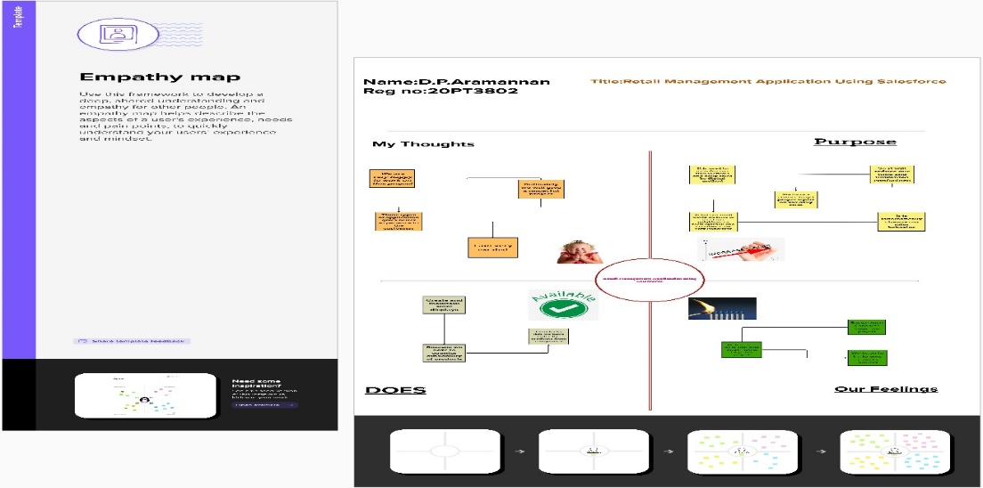

2.2 Ideation & Brainstorming Map:

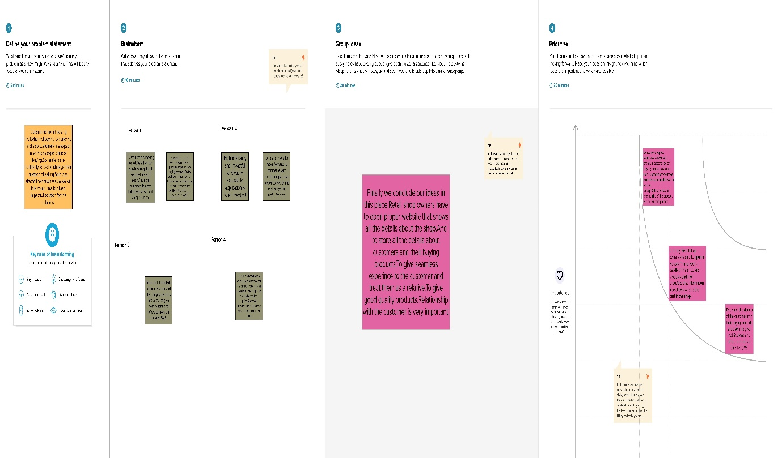

**3.Result**

3.1 Data Model :

|  |  |
| --- | --- |
| **Object Name** | **Field In The Object** |
| Dispatch/Tracking ID | |  |  | | --- | --- | | **Field Label** | **Data Type** | | Dispatch/Tracking | Master Detail Relationship | |

|  |  |
| --- | --- |
| **Object Name** | **Field In The Object** |
| Phone Number | |  |  | | --- | --- | | **Field Label** | **Data Type** | | Phone | Phone | |

**4. Trailhead Profile Public URL**

**Team Leader :** <https://trailblazer.me/id/aro135>

**Team Member 1:** [**https://trailblazer.me/id/aadhs4**](https://trailblazer.me/id/aadhs4)

**Team Member 2:** <https://trailblazer.me/id/ariks3>

**Team Member 3:** [**https://trailblazer.me/id/gilbs1**](https://trailblazer.me/id/gilbs1)

**5.Advantages & Disvantages:**

**Advantages:**

* It reduces stress.
* It saves our time.
* We can store lot of details.

**Disadvantages:**

* If the server is overload it might tough to access the data.
* It causes health issues.

**6. Applicatons :**

* This application is used to store the customer data,which the the retailer can then use to reach out to customers.Through email with personalized offers or with mail offers.
* Retailers can search up customers information to make their experience efficient and quick.

**7.Conclusion :**

We conclude what we know about this,it will be used to digitalize the data of the customer,it gives seamless experience to the customer.This type of software can lead the shopping to digital method.

**8.Future Scope :**

Now a days youths are preferring E-Commerce websites than offline shopping.Because they stored our data and giving lot of offers and send some notifications about many products.So these type of software give lot job opportunities to the customers.Hope it will give impact on the retail management system.